**POWER BI ASSIGNMENT-9**

Use Case – Series Insights

Source- Series File

Analytics – Ranking Series

The data set for this assignment is Series.xlsx. The Particular dataset has been loaded into the Power Bi application from Get Data 🡪 Excel option as shown below

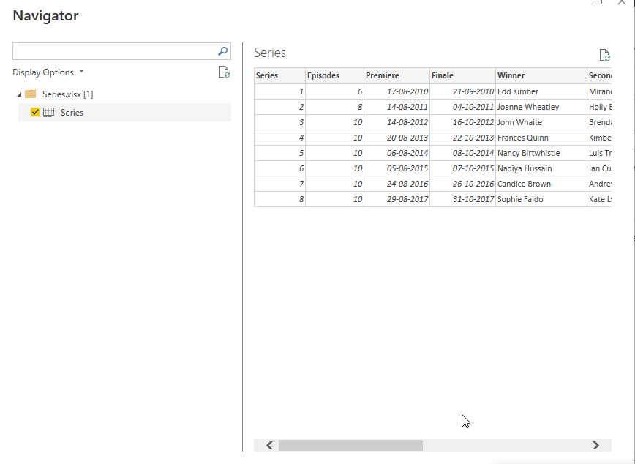

The task is to create a measure of rank based on each series. To perform this task a new measure has been created based on the below formula

Q1. Create a measure(not a calculated column) to rank each series by its viewing figures to get:

Step-1. Rank Series = RANK(ALL(Series), CALCULATE(SUM(Series[Viewers(m)])),,ASC)

A New table visual has been selected and the respective columns has been dragged and dropped along with Rank measure and the final report has been shown below

